BMS COLLEGE OF ENGINEERING
(Autonomous College under VTU)
Bull Temple Road, Basavanagudi, Bangalore - 560019


A report on

“C program to find Eigen Vectors and Eigen Values using Rayleigh Power Method”

Submitted in partial fulfilment of the requirements for the Activity Plan

BACHELOR OF ENGINEERING IN MECHANICAL ENGINEERING

BY-
MANU PRASAD L (1BM21ME055) MAYUR ANAND(1BM21ME057)

Under the guidance of

Dr Sowmya.K.S
Assistant Professor, Department of Information Science and Engineering

Department of Mechanical Engineering 2021-22

`
BMS COLLEGE OF ENGINEERING
(Autonomous College under VTU)
Bull Temple Road, Basavanagudi, Bangalore – 560019
Department of Medical Electronics

C E R T I F I C A T E

This is to certify that the report on “C program to find Eigen Vector and Eigen Values using Power method” is a bona-fide work carried out by Manu prasad L and Mayur Anand as a part of An Activity Plan for the Course PROBLEM- SOLVING THROUGH PROGRAMMING with course code 211CC1ESPSP/ 211CC2ESPSP in Department of Mechanical Engineering from Visvesvaraya Technological University, Belgaum during the year 2021-
22. It is certified that all corrections/suggestions indicated for Internal Assessments have been incorporated in the report deposited in the departmental library.

Prof. Sowmya K.S Assistant Professor, Department of ISE,
BMS college of Engineering

Acknowledgements
We would like to thank our guide, Prof. Sowmya K.S for her patience, first and foremost, and guidance throughout this project. With her support and help, this project rose from the ground up.

Lastly, we would like to thank our college, BMS College of Engineering, for providing us with opportunities to develop new and creative projects.

TABLE OF CONTENTS

SL. NO. | TITLE | PAGE NO.
1 | Introduction | 05
1.1 | Problem Definition | 06
1.2 | Scope | 07
1.3 | Abstract | 08
2 | Project Flow | 09
3 | Implementation | 12
4 | Experimental Analysis and Results | 16
5 | Conclusion | 17
6 | GIThub link

Introduction
Eigen value
Eigenvalues are the special set of scalars associated with the system of linear equations. It is mostly used in matrix equations. ‘Eigen’ is a German word that means ‘proper’ or ‘characteristic’. Therefore, the term eigenvalue can be termed as characteristic value, characteristic root, proper values or latent roots as well. In simple words, the eigenvalue is a scalar that is used to transform the eigenvector.
Eigen Vectors
Eigenvectors are the vectors (non-zero) that do not change the direction when any linear transformation is applied. It changes by only a scalar factor. In a brief, we can say, if A is a linear transformation from a vector space V and x is a vector in V, which is not a zero vector, then v is an eigenvector of A if A(X) is a scalar multiple of x.

Problem Definition
The solution to real-world problems often depends upon processing large volume of data representing different variables or dimensions. Using large number of independent variables (also called features), training one or more machine learning models for predicting an output in any application will be computationally intensive. Hence such complex is taken and divided into smaller set of variables(sub-features) for easy computation, while the original variables are retained.

Scope

Eigenvalues are often introduced in the context of linear algebra or matrix theory. Historically, however, they arose in the study of quadratic forms and differential equations.

In the early 19th century, Augustin-Louis Cauchy saw how their work could be used to classify the quadric surfaces, and generalized it to arbitrary dimensions. Cauchy also coined the term racine caractéristique (characteristic root), for what is now called eigenvalue; his term survives in characteristic equation.Later, Joseph Fourier used the work of Lagrange and Pierre-Simon Laplace to solve the heat equation by separation of variables.

Around the same time, Francesco Brioschi proved that the eigenvalues of orthogonal matrices lie on the unit circle, and Alfred Clebsch found the corresponding result for skew-symmetric matrices. Finally, Karl Weierstrass clarified an important aspect in the stability theory started by Laplace, by realizing that defective matrices can cause instability.

In the meantime, Joseph Liouville studied eigenvalue problems similar to those of Sturm; the discipline that grew out of their work is now called Sturm–Liouville theory. Schwarz studied the first eigenvalue of Laplace's equation on general domains towards the end of the 19th century, while Poincaré studied Poisson's equation a few years later.

At the start of the 20th century, David Hilbert studied the eigenvalues of integral operators by viewing the operators as infinite matrices. He was the first to use the German word eigen, which means "own", to denote eigenvalues and eigenvectors in 1904, though he may have been following a related usage by Hermann von Helmholtz. For some time, the standard term in English was "proper value", but the more distinctive term "eigenvalue" is the standard today.

The first numerical algorithm for computing eigenvalues and eigenvectors appeared in 1929, when Richard von Mises published the power method. One of the most popular methods today, the QR algorithm, was proposed independently by John G. F. Francis and Vera Kublanovskaya in 1961.

Finding Eigenvalues and Eigenvectors of a matrix can be useful for solving problems in several fields such as some of the following wherever there is a need for transforming large volume of multi-dimensional data into another subspace comprising of smaller dimensions while retaining most information stored in original data. The primary goal is to achieve optimal computational efficiency.

- Communication systems: Eigenvalues were used by Claude Shannon to determine the theoretical limit to how much information can be transmitted through a communication medium like your telephone line or through the air. This is done by calculating the eigenvectors and eigenvalues of the communication channel (expressed a matrix), and then waterfilling on the eigenvalues. The eigenvalues are then, in essence, the gains of the fundamental modes of the channel, which themselves are captured by the eigenvectors.

- Designing bridges: The natural frequency of the bridge is the eigenvalue of smallest magnitude of a system that models the bridge. The engineers exploit this knowledge to ensure the stability of their constructions. [Watch the video on the collapse of the Tacoma Narrow Bridge which was built in 1940].

- Designing car stereo system: Eigenvalue analysis is also used in the design of the car stereo systems, where it helps to reproduce the vibration of the car due to the music.

- Electrical Engineering: The application of eigenvalues and eigenvectors is useful for decoupling three-phase systems through symmetrical component transformation.

- Mechanical Engineering: Eigenvalues and eigenvectors allow us to "reduce" a linear operation to separate, simpler, problems. For example, if a stress is applied to a "plastic" solid, the deformation can be dissected into "principle directions"- those directions in which the deformation is greatest. Vectors in the principle directions are the eigenvectors and the percentage deformation in each principle direction is the corresponding eigenvalue.

Thus, it can be said that Eigen values and Eigen vectors concepts are key to training computationally efficient and high performing machine learning models, which is helpful for data scientists.

Abstract
Eigen vectors are the non-zero vectors that do not change the direction when any linear transformation is applied. It changes by only a scalar factor.
Let us say “A” is an n × n matrix and “λ” is an eigenvalue of matrix A, then “x”, a non-zero vector, is called as Eigen vector if it satisfies the given below expression:

Ax = λx
The scalar value “λ” is an Eigen value of A. And “x” is the Eigen vector.
- Aim is to write a C Program to find “λ” and “x.”

The C concepts required here are:
- For loops
- Do while loop

Project Flow

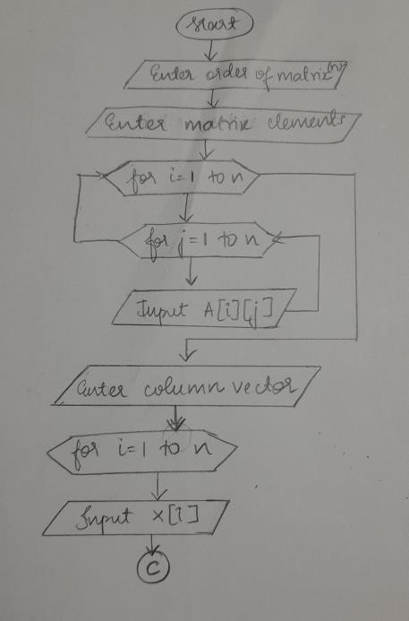

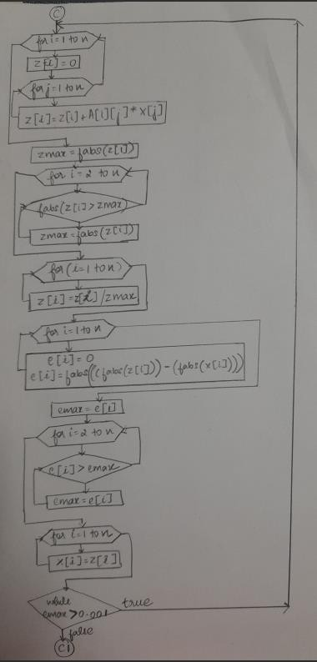

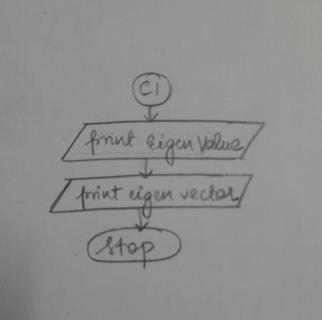

- Implementation
To write a C program it is first essential to find out how the flow of the program must be. In other words, a better understanding of the program in simple words understandable by the programmer is always required before writing an actual program. This can be done by writing an algorithm.

Algorithm
Step 1: Start
Step 2: Declare i, j, n, A[40][40], x[40], z[40], e[40], zmax, emax; Step 3: Input n
Step 4: For i=1 to n and j=1 to n Input A[i][j]
Step 5: For i=1 to n
Input x[i]
Step 6: Do steps 6-12 while(emax>0.001)
Step 7: For i=1 to n
z[i]=0;
For j=1 to n Z[i]=A[i][j]*x[j]; End of for
End of for
Step 8: zmax=fabs(z[1]);
For i=2 to n if((fabs(z[i]))>zmax) zmax=fabs(z[i]); else goto step 7
End of for Step 9: for i=1 to n
z[i]=z[i]/zmax; End of for
Step 10: For i=1 to n
e[i]=0;
e[i]=fabs((fabs(z[i]))-(fabs(x[i])));

End of for Step 11: emax=e[1];
Step 12: For i=2 to n
if(e[i]>emax) emax=e[i];
else goto step 12 End of for
Step 13: For i=1 to n
x[i]=z[i]; End of for
Step 14: Print “The required eigen value is, zmax” Print “The required eigen vector is: "
For i=1 to n print “z[i]\t” End of for
Step 15: Stop

C Program

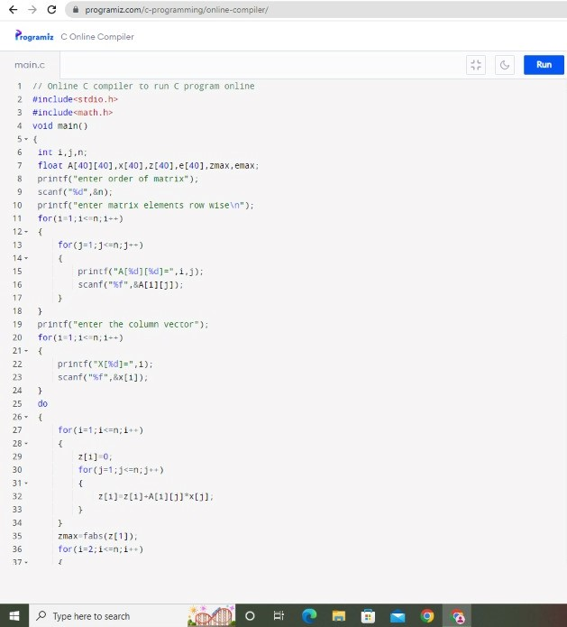

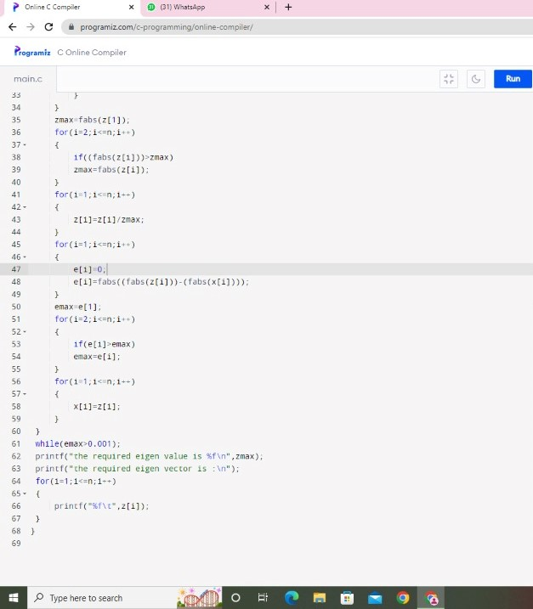

Experimental Analysis and Results
The results so obtained are accurate. The final values can be checked by manually solving it as well.
The first output is of a 2x2 matrix having 2 Eigen Vectors:
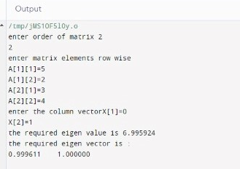

The second output is of a 3x3 matrix having 3 Eigen Vectors:

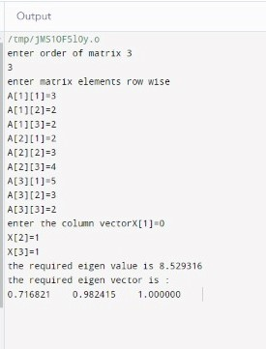

Conclusion
A Computer Code or program helps us find solution to any problem faster. This C program helped us find the Eigen Values and the Eigen Vectors in just a matter of few seconds while the actual process would have taken minutes together. Matrix multiplication has never been easy, the traditional method of find the Eigen Vectors and Eigen Value involves a lot of steps that take time for us to do on paper. But computing a program helps find solutions faster, this program is focused on reducing the time taken for each complex step and to give the most accurate results for a wider application in real life sectors.

